**Redux**

Redux is a state Management store.it will control globe state manages in the react.

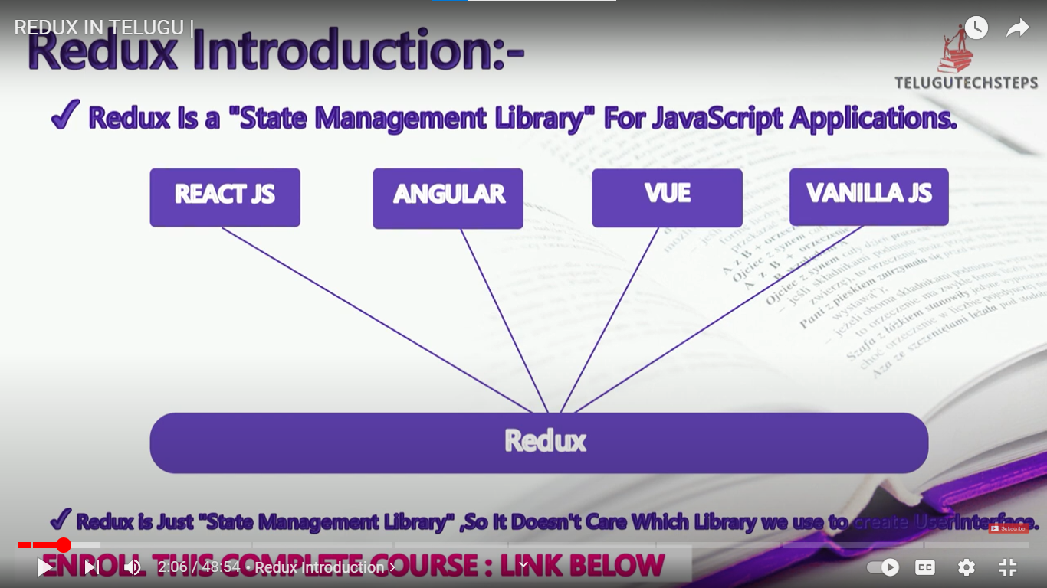

Redux can use any library like reactjs, angular, Vue js and vanilla js etc.,

Why we use Redux?



How to manage state in Redux?

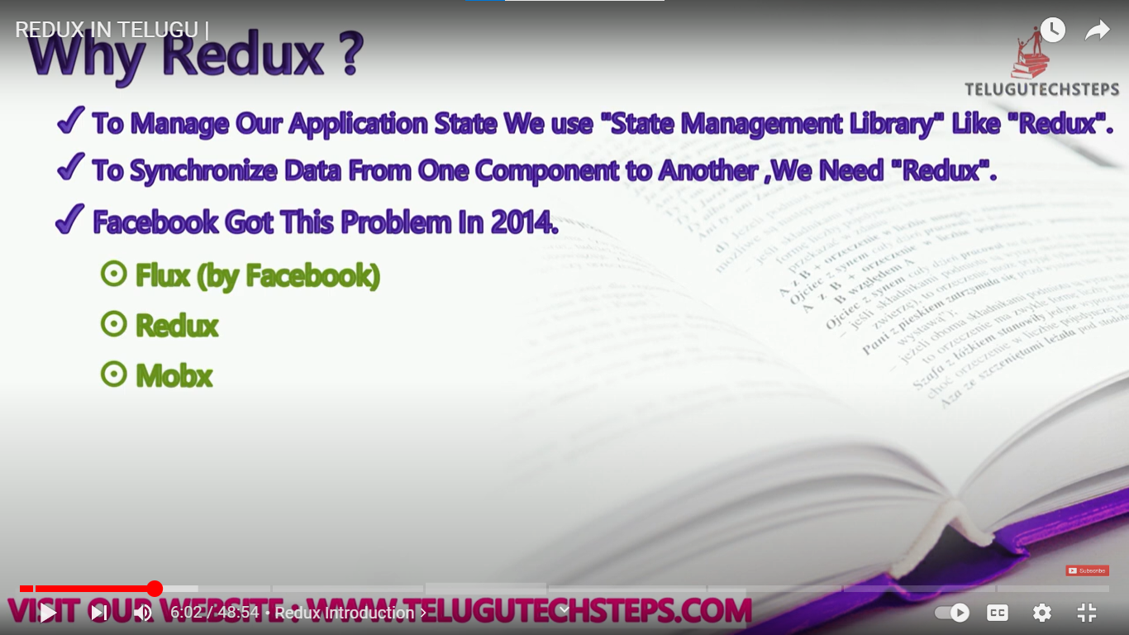

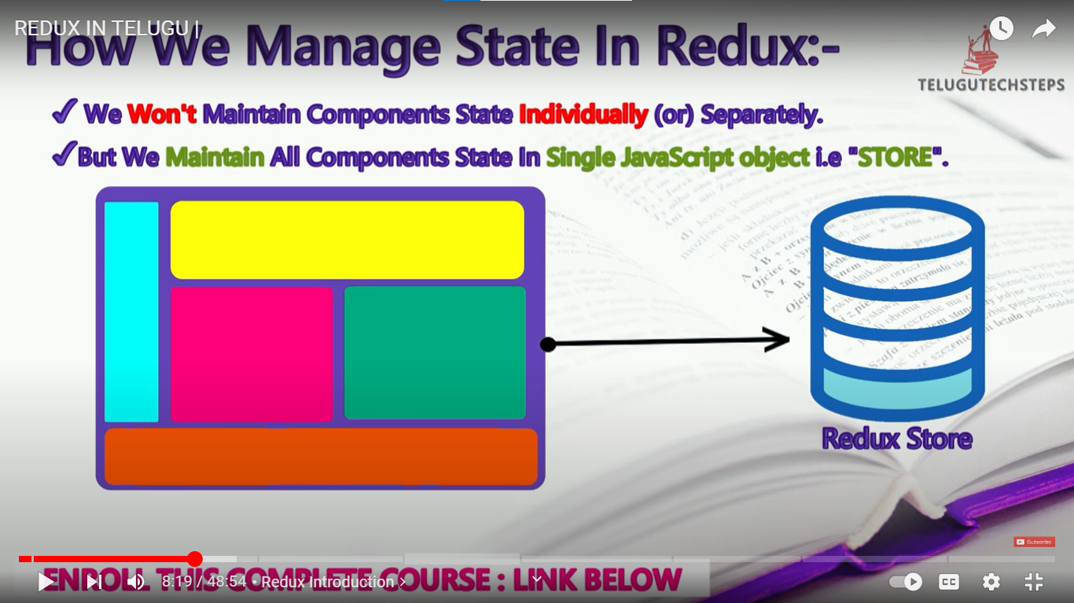

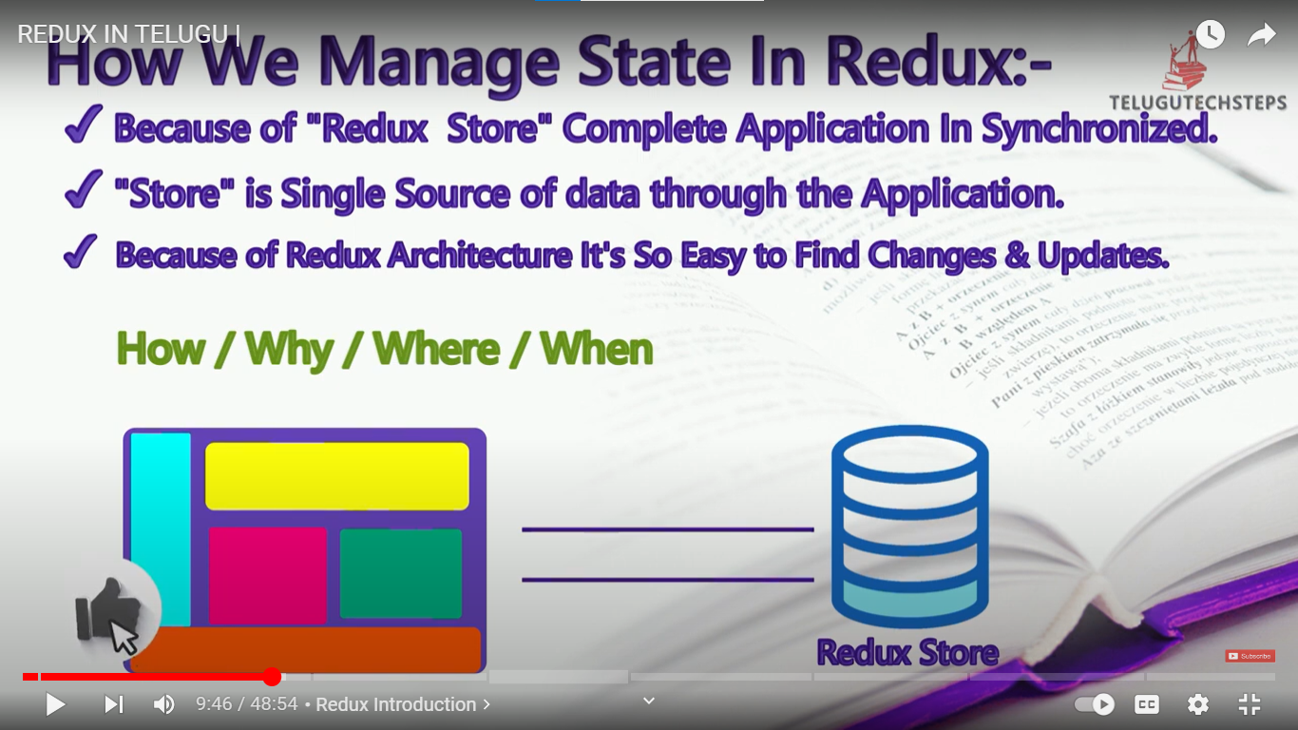

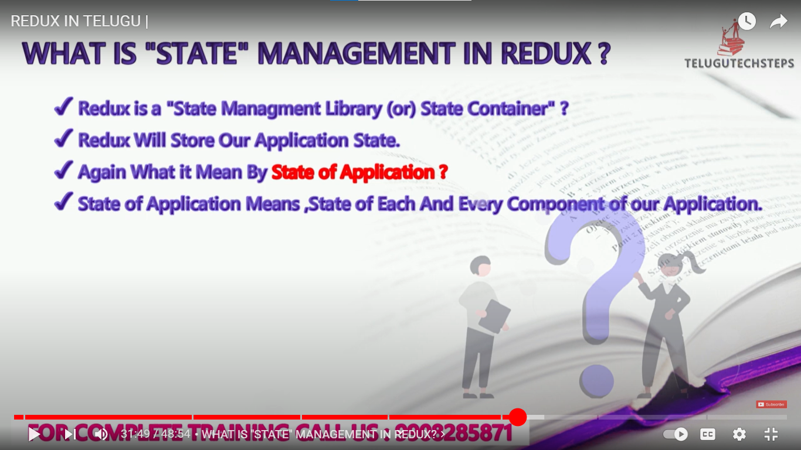

CORE Principles of Redux:-

